**October 27th, 2019**

Corporate Office:

Rupayan Shelford - Level 14

23/6, Mirpur Road, Shyamoli

Dhaka-1207, Bangladesh

Phone: +880-1919968025

Email: ratan.rahman@dma-bd.com

This is a proposal for the implementation of IoT system on a Metal Private Limited inventory to monitor the real-time data from the datacenter. It is our pleasure that we can provide you the GPS Tracking system with the integration of data loggers and sensors on the field equipment. The IoT devices will provide the telemetry data over the GPRS to the datacenter to expand the automation process after the piloting.

**Ratan – Hasan Rahman, MD**

Datasoft Manufacturing & Assembly Inc. LTD Dhaka, Bangladesh

|  |  |
| --- | --- |
| Metal Private limited IoT Proposal  IoT Based data system - Monitoring System from Datacenter | Abstract |



Dated: October 27th, 2019

To: Mr. Farhad, Managing Director

Metal Private Limited

Gulshan-2 Dhaka -1212

Subject: Proposal for GPS & IoT Implementation on Metal Private Ltd. /equipment

Dear Mr. Farhad:

This is a proposal for the implementation of Iot based GPS System for the Metal Private Limited. It is our pleasure that we can provide you GPS Tracking system for tractors, Diesel Generators and portable generators to expand the automation process that is to identify the operational conditions in real-time over a dashboard and mobile apps. Our IoT GPS solution will provide the real-time data to the datacenter for controls & monitoring. To manage the activities we will provide you a Dashboard (i.e. User Interface Panel) on your site whereby you be able to control and monitor of each activities and also be able to manage all the equipment with our IoT devices from online dashboard.

The initial purpose is to bring under monitoring of tractors, Diesel Generators and portable generators within the dashboard. As a pilot project we can provide you our Datasoft Manufacturing GPS Tracking system. The products are manufactured and assembled in Bangabandhu HiTech City at Kaliakoir, Gazipur, Bangladesh. The whole system will be installed and implemented with our own brand.

This GPS & IoT system implementation totally eliminates the need of manual operations. The on-site dashboard will provide you the real-time configuration and administrative information along with any repair or replacement of the malfunctioned equipment. In Metal Private, the GPS Tracking System can provide the accurate information without investing any other resources to do the maintenance, system operation and where about.

Sincerely Yours;



Hasan Rahman, MD

Datasoft Manufacturing & Assembly Inc. Limited

1. **COMPANY AT A GLANCE**

Datasoft Manufacturing is a leading designer and development of data system in monitoring field operation for Tractors, Diesel Generators and portable generators using GPS Tracking and IoT based sensors. We have provided IoT and GPS devices for different field operations with innovative IoT solutions, and with IoT system implementation.

Our IoT solutions provide a lower total cost of ownership and fewer trips to the field. Our devices, telemetry systems, and data services platform were built for easy integration and user-friendly operation to access and control your operation has never been this easy.

Our team of experts is ready to help you find the right solution for your project, and our support team always standing by to offer complimentary 24/7 technical support and mobile help in the field.

Our GPS & IoT system will enable Metal Private Ltd successful migration toward the automation and will be satisfied with the performance in maintaining all the equipment more efficiently. And also with the dashboard to extend it up to the user level for Monitoring and maintenance of the equipment.

This GPS & IoT system implementation will totally automates each equipment. The dashboard will provide you the real-time for Tractors, Diesel Generators and portable generators status, configuration and administrative information of the equipment along with any repair or replacement of any malfunctions equipment’s. Datasoft Manufacturing will also integrate the Collections of loan from each farmer by a mobile apps for accurately collecting the loan without investing any more resources into the GPS & IoT system.

1. **SCOPE OF WORK**

The purpose of this document is specification of Centralized IoT platform for GPS & IoT System and how it will provide data related to features and performance implemented by the Datasoft Manufacturing.

The Datasoft Manufacturing will comply based on International Standards upon the actual installation of the hardware/software. If the requested feature is not available in the release, then the Datasoft Manufacturing shall indicate in which release it is foreseen and indicate the availability date.

For each requirement or specification, the Datasoft shall answer in Response either Compliant or Partially Compliant or Not Compliant:

* **Compliant**, if the proposed system entirely complies with the requirement. In addition, where requested, the Datasoft Manufacturing will provide with relevant technical details and specific benefits of its implementation.
* **Partially Compliant**, if the proposed system complies in part with the requirement or if the requirement will be fulfilled in a later release. Datasoft Manufacturing will indicate in which respect its implementation does not comply.
* **Not Compliant**, if the proposed system does not comply with the requirement. Datasoft Manufacturing will NOT provide an alternative or partial solution.

1. **REQUIREMENTS**

The reference tables provides the Initial requirements to install and implement GPS & IoT system in one of the equipment to extend the automation and subsequently convert other equipment s for Metal Private Ltd.

Installation of GPS & IoT system on a typical equipment, will be visited and surveyed to determine the actual condition of all the meters and pumps with an inspection of the full infrastructures and power sources. We will get the project started by:

* As Is Sign Off equipment infrastructure
* GPS & IoT data-loggers and sensors Implementation
* GPRS SIM Cards & Network for Telemetry
* Determine the schedule for Go Live & Monitor the GPS & IoT on Metal Private Ltd. site
* Annual full Maintenance, one (1) year from the implementation.
* UAT (User Acceptance) Sign Off

At present data can be acquired from the following parameters:

* Monitor and track their field agent and provide real-time location and schedule.
* Mobile apps to track the agent (money collector’s) activities for their loan collection, which includes the address of the farmers the collector visits regularly.
* Monitor the generator based on ON/OFF sequence to determine the fuel consumption using software analytics of the generator profile.

**Requirements for Mobile Apps:**

There are 2 mobile apps: one to transmit GPS data another to display the real-time and playback of GPS tracking:

* **Admin App**
* **Agent App**

**Agent App:**

* Login as Agent
* Agent app will generate QR code, so admin can assign GPS device to agent.
* After receiving push notification from admin, agent app will start transmit GPS data.
* Send starting location’s GPS data to server.
* Send GPS data to server after 3 minutes of interval.
* Agent must submit photo, address, collected amount of the client from whom he collects installment.
* Calculate waiting duration, if time cross threshold min/max time app will send notification to server.

**Admin App:**

* Login as Admin
* Admin will assign GPS device by scanning QR code.
* Admin will schedule agent’s collection time and route.
* Select an agent from agent list to track agent.
* Selected agent details will display in map during the tracking.
* If any tampering of the device happens, admin will receive push notification and switched to the backup device (Secondary device) for transmitting data.

All these data are fed via cables to a **multi deployable wireless data logger** at each equipment location which stores data and sends Data via GPRS Telecommunication Towers to the datacenter in Metal Private Ltd. Datasoft will deploy the Telemetry system to acquire, archive, analyze and command/controls the sensors from the dashboard from the main server in Metal Private Ltd. Data center. The dashboard will show the graphical and Textual Data display along with all the parameters in real-time. Engineers can also use smart phones to access the apps to know the present status and, if required, to switch on and off any equipment remotely.

**Overall Requirements**

|  |  |  |  |  |  |
| --- | --- | --- | --- | --- | --- |
| Item | | Description | | Requirements | |
| 1 | | Quality | | Internationally recognized and quality assurance software for IoT market and certified by IoT Commmunity | |
| 2 | | International Certification | | The platform should be able to carry out international certification of devices | |
| 3 | | Brand | | Datasoft Manufacturing & Assembly | |
| 4 | | Model | | Datasoft Manufacturing & Assembly | |
| 5 | | Country of origin | | Bangladesh | |
| 6 | | Country of Manufacture | | Bangladesh | |
| 7 | | Product | | Centralized IoT platform for GPS & IoT Systems | |
| 8 | | **Communications** | | | |
| 9 | |  | | The GPS & IoT system will adapt to any device related protocols for example - Wireless Modbus TCP, MODBUS RTU, RS-232/422/485, GPRS, M2M, TCP/IP, SMS, MQTTS, HTTP/HTTPS,WiFi, Ethernet,serial, etc. International Standard & open communication protocol. | |
| 10 | |  | | GPS & IoT will be able to Control feild devices or sensors by International Society of Automation (ISA) and IEC standards and follow the above any communication standards or interface to communicate with remote devices. | |
| 11 | |  | | The system will be device-agnostic, to allow any above communicating device to connect with the platform. | |
| 12 | |  | | The system will provide automatically or manually assign a GPS location to each sensor for placing on a GIS map. | |
| 13 | |  | | The user interfaces will provide a dashboard using Web technologies, supporting secure layer HTTPS. | |
| 14 | |  | | The system will gather, store and correlate high-volume, time-series data with structured and unstructured data. Time-series, structured and unstructured data should be stored and correlated properly. | |
| 15 | |  | | The Accounts will be partitioned into three types: Operator, Test, and Admin. | |
| 16 | |  | | GPS & IoT system will provide a dashboard for User Interface. It will provide the visibility of the location and data from sensors. | |
| 17 | |  | | Enable/disable mobile station functions (usage of Wi-Fi, ports etc.); | |
| 18 | |  | | Backup/restore mobile device data; | |
| 19 | |  | | Perform a full or partial device cleanup; | |
| 20 | |  | | Remote monitoring and managing of M2M-device software; | |
| 21 | |  | | PIN code and password usage; | |
| 22 | |  | | Remote enabling/disabling M2M device features (configuring a scheduled operation); | |
| 23 | |  | | Data backup, copying data, data recovery, deleting data from M2M-terminal; | |
| 24 | |  | | Creation, storage and application of configuration templates; | |
| 25 | |  | | Function, which allows to remotely lock a terminal and delete its data; | |
| 26 | |  | | Monitoring changes of specified configuration options and change notifications | |
| 27 | |  | | Logging M2M-device operations; | |
| 28 | |  | | Logging device access attempts; | |
| 29 | | **Dashboard Features** | | | |
| 30 | |  | | The system will provide to collect information and/or alarm messages/notifications from devices including application data depending on a device assignment; | |
| 31 | |  | | The system will provide notifications in the interface, through an e-mail, SMS, push messages on specific events | |
| 32 | |  | | The system will provide secure transmission of a received information to external systems through supported interworking protocols. | |
| 33 | |  | | Remote Reboot, switching on/off | |
| 34 | |  | | The system will be enabled Over the Air (OTA) firmware update. | |
| 35 | |  | | The system will support MQTT | |
| 36 | |  | | The Device will support of AT-command libraries | |
| 37 | |  | | Thesystem will provide creation and assigning of consumption alarm and action profiles by the customer to its subscription in the portal and the API. | |
| 38 | |  | | Temporary barring of all traffic per subscription. | |
| 39 | |  | | The system will provide the Maximum Data and SMS from month to date | |
| 40 | |  | | The system will provide reports, to email these and to load to external systems. | |
| 41 | |  | | Selected data will be displayed as graphs and diagrams. | |
| 42 | |  | | Data analytics and interpretation will be provided on received from devices. The document describing systems features will be provided. | |
| 43 | |  | | The system will provide Analytics with real-time pattern & anomaly detection, automated predictions, simulation and prescriptive analysis. | |
| 44 | | **Tractor Information** | | | |
| 45 | |  | | Cultivation status (Whether the tractor is being used in the field or not) | |
| 46 | |  | | Haulage status (Whether the tractor is being used in transportation or not) | |
| 47 | |  | | Fuel consumption status (Fuel level indicator in the form of percentage or fuel gauge animation) | |
| 48 | |  | | Total running distance (Odometer style distance travelled ) | |
| 49 | |  | | Starting hour | |
| 50 | |  | | Ending hour Remote Immobilize any tractor through app (Remotely shut down the engine of the tractor) | |
| 51 | |  | | Track the tractor (Live movement of the tractor with trails) | |
| 52 | |  | | Track nearby workshop (Static marker showing location of the nearby service station) | |
| 53 | |  | | Notification alert for servicing | |
| 54 | |  | | Get odometer reading of tractor | |
| 55 | |  | | GPS status/coordinates | |
| 56 | |  | | Notification alert for servicing, cable damage | |
| 57 | |  | | Monitor fuel | |
| 58 | | **Portable Generator (PG) Information** | | | |
| 59 | |  | | Cellular operator of a location network | |
| 60 | |  | | MSISDN | |
| 61 | |  | | Radio signal strength | |
| 62 | |  | | Portable Generator (PG) model | |
| 63 | |  | | Operational status | |
| 64 | |  | | Fuel consumption | |
| 65 | |  | | Total running hour | |
| 66 | |  | | Starting hour | |
| 67 | |  | | Ending hour | |
| 68 | |  | | Immobilize any PG through app | |
| 69 | |  | | Track the PG | |
| 70 | |  | | Get odometer reading of tractor | |
| 71 | |  | | GPS status/coordinates | |
| 72 | |  | | Notification alert for servicing, cable damage | |
| 73 | |  | | Monitor fuel | |

|  |  |  |
| --- | --- | --- |
| 74 | **Diesel Generator (DG) Information** | |
| 75 |  | Cellular operator of a location network |
| 76 |  | MSISDN |
| 77 |  | DG model |
| 78 |  | Operational status |
| 79 |  | Fuel consumption |
| 80 |  | Total running hour |
| 81 |  | Starting hour |
| 82 |  | Ending hour |
| 83 |  | Immobilize any DG through app |
| 84 |  | Track the tractor |
| 85 |  | Get odometer reading of tractor |
| 86 |  | Notification alert for servicing, cable damage |
| 87 |  | Monitor fuel or refueling |
| 88 | **Remote Operations** | |
| 89 |  | Status on Acquisition of Data |
| 90 |  | On Demand Information |
| 91 |  | Event history and Fault Management |
| 92 |  | Reliability indices reporting capabilities |
| 93 |  | Remote connect/disconnect of devices |
| 94 |  | Remote firmware upgrades/ downgrades/ management for individual or groups of devices |
| 95 |  | Data reading management (configures read schedules, processes readings, performs on- demand readings, etc.) for single, grouped, and arbitrary sets of devices. |
| 96 |  | Role-based access control |
| 97 |  | Mobile apps for Data System interface |
| 98 |  | Date and time |
| 99 |  | Raw interval data (real, reactive, apparent per configuration) and profile data |
| 100 |  | Events, such as tamper detected and last gasp alerts |
| 101 |  | Right to execute operations such as reading, disconnection, reconnection, etc. |
| 102 |  | Manage Devices |
| 103 |  | Add/Remove/Edit User Accounts |
| 104 |  | ·         Application Level Security |
| 105 |  | ·         Access Level Security |
| 106 |  | ·         Device Level Security |
|  |  |  |

1. **Mobile Apps Wireframe:**

Our services and applications are designed to give you field-ready durability with accurate results you can trust. Whether you need to measure fuel volume, location, or another parameter, we’ve got your testing needs covered. Datasoft Manufacturing will provide you handheld mobile apps that’s right for your needs!

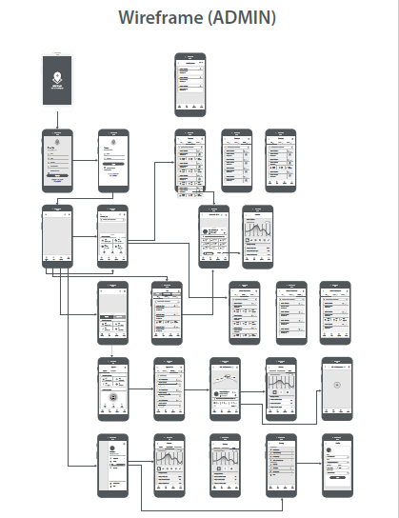

1. **Tractor GPS Tracker:**

The GPS tracker quality testing equipment is designed to give you field-ready durability with accurate results you can trust. This device can measure fuel volume, geo-fencing, real-time tracking, over-speed alarm, low battery alarm or another parameter, we’ve got the device quality tested and it will be installed in the tractors:

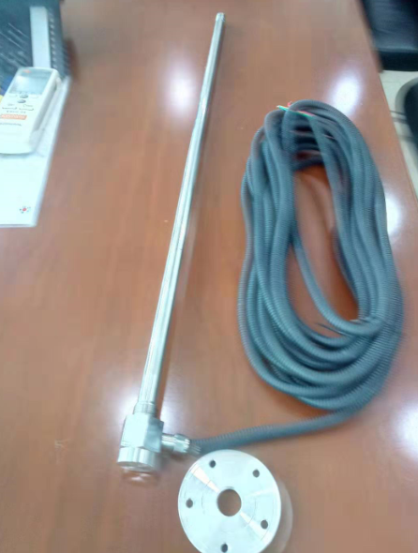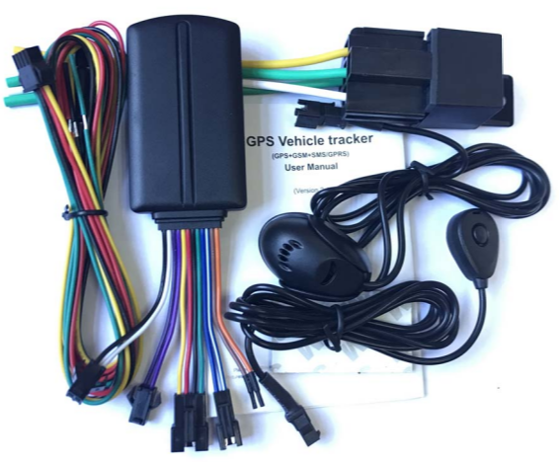

**5.1 Portable/Diesel Generator Tracking Devices**

This device can measure fuel volume, geo-fencing, real-time tracking, low battery alarm or another parameter, we have tested the device quality and it will be installed in the PG and DG:

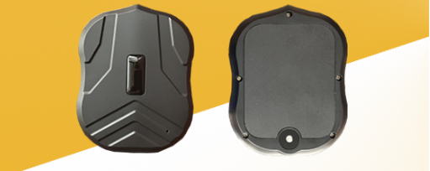

**6.0 SCOPE WISE DEAD LINES / PROJECT IMPLEMENTATION PLAN:**

Datasoft Manufacturing initially will study and understand the scope of work to make sure Datasoft can address all GPS & IoT needs that Metal Private Ltd. is required. Now Datasoft will sit with the stake holders for details understanding of the GPS & IoT to prepare the **Current Business Practice (AS IS)**.

Datasoft Manufacturing will provide a dashboard to the Metal Private Ltd. technical team of the above said actions immediately upon on a Work Order (WO) is given by this year and the asked Initiation Advance by on or before December 31st 2019. The delivery dates will be backing off or coming up depending on the related initiation dates. Datasoft Manufacturing will have a Project Status shared with Metal Private Ltd. Team once the configuration of the GPS & IoT project started, so both the parties are aware of the progress.

**Training** will start after the completion of the GPS & IoT System setup. Training will be on the usage of the GPS & IoT dashboard. Training is not limited to number of users. If the above GPS & IoT configuration goes smoothly, Datasoft is planning to declare **Go Live** of Metal Private Ltd. Implementation on a given schedule.

On the **Post Go Live Support**, that is the 1st Year from the Go Live Date, Datasoft will provide Metal Private Ltd. with the below Issues:

* GPS & IoT Application Bug
* Hardware Services
* New Problems
* Dashboard Service